Caption Generator For Images Powered By Watson Visual Recognition
1.Introduction:
Image Captioning refers to the process of generating textual description from an image – based on the objects and actions in the image. The ability to recognize image features and generate accurate, syntactically reasonable text descriptions is important for many tasks in computer vision. for example, you can consider following applications
Self-driving cars — Automatic driving is one of the biggest challenges and if we can properly caption the scene around the car, it can give a boost to the self-driving system.
Aid to the blind — We can create a product for the blind which will guide them travelling on the roads without the support of anyone else. We can do this by first converting the scene into text and then the text to voice. Both are now famous applications of DeepLearning.
CCTV cameras are everywhere today, but along with viewing the world, if we can also generate relevant captions, then we can raise alarms as soon as there is some malicious activity going on somewhere. This could probably help reduce some crime and/or accidents.
2. Flow diagram of Project:

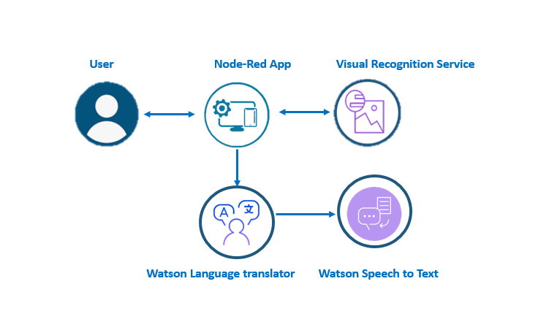

3.Services Used:
- IBM Watson Studio
- IBM visual recognization
- Node-RED
- IBM Cloud Object Storage
4. Work flow of an project
1. Create a account in cloud.ibm.com
2.Create a necesary serives
i)IBM Watson Studio
ii)IBM Watson visual recognization adn note down the API and URL
iii)IBM Watson Speech recognizaton and make a note of API and url
iii) Associate the cloudstorage sevice
3. open the node-red services provided
i) Buid web application using Node-red
ii) install the dash-board to include the form
iii)Add template node and is used to define the form
iv) Add visual recognization node to recognize the image
v)Add the text to speech node that is used to convert caption generated to
the audio
iii) Add the appropraite endpoint to the node.
ii)And deploy it

output:
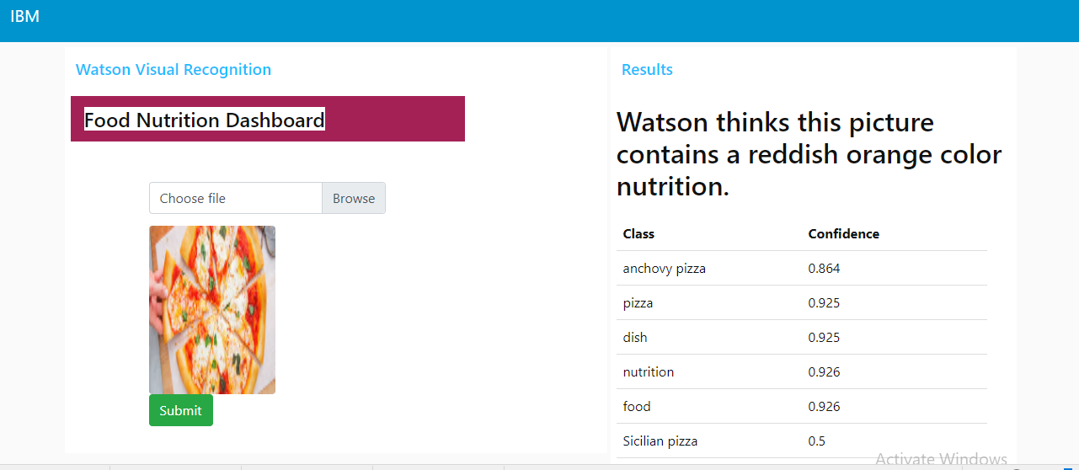
Conclusion
Caption Generator For Images Powered By Watson Visual Recognition was developed .It visually Analysis the image uploaded and generate the caption and that caption is converted to audio.

